Github repo link: https://github.com/Chaurasia-Rahul/dhwani_mage.git

1: open visual studio

2: in “View” click command pallet

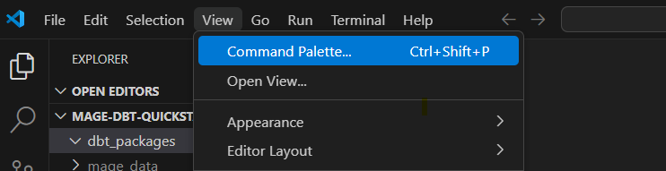

3: under search bar type git and select GIT clone and paste the link in the bar.



4: On pop-up window select the destination where you need to clone the code.

5: when the files is copied, rename the env file to **.**env.

Now Open Powershell:

Switch to directory where you have cloned the repo and enter the commands:

Cd path

Docker compose up –build

Done!!